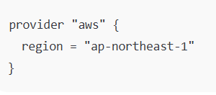
Default Provider
This is the default AWS provider configuration.
Any AWS resource that doesn’t specify a provider = ... will use this one.

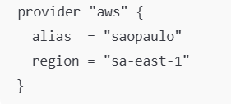
Aliased Provider
This is a second AWS provider configuration
You use it when you want specific resources created in another region

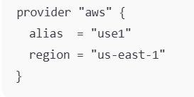
Aliased Provider (US East 1)
Common reason in your setups: ACM certificates for CloudFront must be in us-east-1 (so you often place cert resources here), and sometimes Route 53-related workflows.

